Planning and Environment Act 1987

GREATER SHEPPARTON PLANNING SCHEME

AMENDMENT C168

EXPLANATORY REPORT

Who is the planning authority?
This amendment has been prepared by Greater Shepparton City Council, which is the planning authority for this amendment.
The Amendment has been made at the request of Chris Smith and Associates Pty Ltd on behalf of the land owner of 335 Rutherford Road, Toolamba.

Land affected by the Amendment
The Amendment applies to land identified in the Toolamba Precinct Structure Plan, September 2018 (the PSP), being 19 Londregan Lane, Toolamba and part of 335 Rutherford Road, Toolamba (lots 4 and 5 on TP825016).
The PSP area is generally bounded by existing township properties along Wren Street to the north, the railway line to the east, the Public Acquisition Overlay for the Goulburn Valley Highway Shepparton Bypass to the south and Rutherford Road to the west.
The PSP area is made up of approximately 54 hectares of land within the Farming Zone – Schedule 1 (see Figure 1 – Zone Map). Part of the land is affected by the Land Subject to Inundation Overlay (LSIO). The southern extent of the PSP area abuts the Public Acquisition Overlay (PAO7) for the Goulburn Valley Highway Shepparton Bypass (see Figure 2 – Overlay Map). The PSP area is known as Investigation Area 6 in the Greater Shepparton Planning Scheme.
Figure 1 – Zone Map
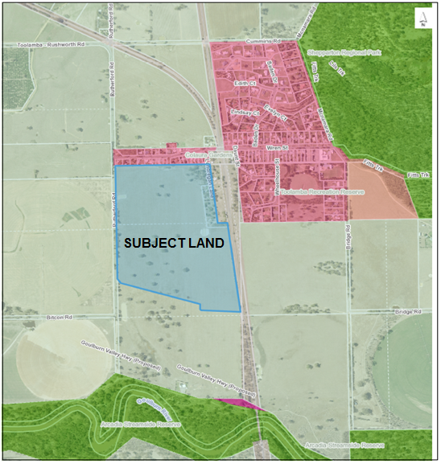
Figure 2 – Overlay Map
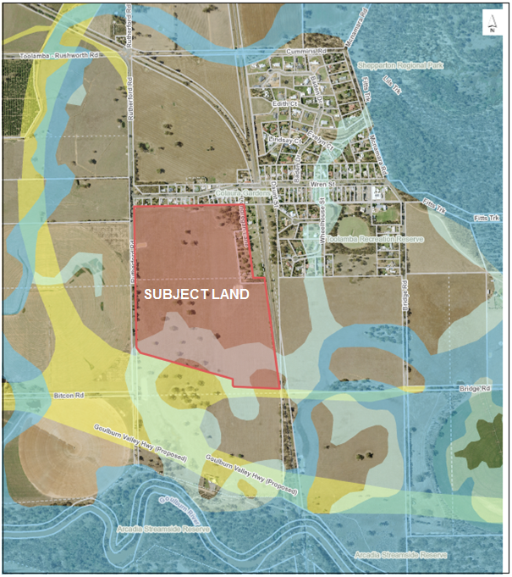

What the amendment does
The Amendment proposes to rezone land from the Farming Zone – Schedule 1 to the Urban Growth Zone – Schedule 3 and implements the Toolamba Precinct Structure Plan, September 2018 into the Greater Shepparton Planning Scheme as an incorporated document. This Explanatory Report is to be read in conjunction with the Toolamba Precinct Structure Plan, September 2018.
Specifically, the Amendment proposes the following changes to the Planning Scheme:
- amends Clause 21.04 Settlement to note that the study of Investigation Area 6 is now completed;
- rezones land from the Farming Zone – Schedule 1 to the Urban Growth Zone – Schedule 3;
- inserts Schedule 3 to Clause 37.07 Urban Growth Zone. The schedule will set out the land use and development controls for the subject site with regards to the Toolamba Precinct Structure Plan, September 2018;
- amends the Schedule to Clause 44.04 Land Subject to Inundation Overlay to exempt single dwellings that are above the 100-year ARI flood level;

- amends the Schedule to Clause 72.04 Schedule to the Documents Incorporated in this Scheme to incorporate the Toolamba Precinct Structure Plan, September 2018; and
- amends Planning Scheme Map No. 33ZN.

Strategic assessment of the Amendment

Why is the Amendment required?
The Amendment is required to implement the findings and recommendations of the Greater Shepparton Housing Strategy 2011, the Greater Shepparton Township Framework Plan Review 2019, and Clause 21.04 Settlement of the Greater Shepparton Planning Scheme.
Greater Shepparton is experiencing increased population growth and changing demographic trends, resulting in demand for a greater amount of housing provision and a variety of housing types. The Amendment will allow the township of Toolamba to grow and become a community supported by a local town centre, community facilities, commercial facilities and a sports ground.
As stipulated in the authorisation of this Amendment, Greater Shepparton City Council has prepared the Toolamba Growth Plan 2020 and the Toolamba Housing and Streetscape Typologies 2020 to provide a vision for the township’s growth, ensuring that residential growth is cohesive and appropriately supported by service and infrastructure provision. Amendment C224, which implements the Toolamba Growth Plan 2020 and the Toolamba Housing and Streetscape Typologies 2020 in the Greater Shepparton Planning Scheme, is intended to progress concurrently with this amendment to maximise net community benefit for present and future residents.
Amendment C168 implements the short-term objectives of the Toolamba Growth Plan 2020, providing necessary zoned residential land supply in response to the gap in supply identified in the Greater Shepparton Township Framework Plan Review 2019.
The subject site is identified as being entirely within Investigation Area 6 in the Toolamba and Old Toolamba Framework Plan at Clause 21.04 Settlement of the Greater Shepparton Planning Scheme. The land is designated as an Investigation Area primarily due to flooding constraints and the current absence of sewerage. The Planning Scheme provides the following information regarding Investigation Area 6:
Investigation Area 6 – Toolamba. The area is located to the south west of the existing township. The density of residential development will be dependent on the outcome of current investigations into the provision of sewerage to the land. In the absence of sewerage, the density of future residential development will be dependent on Land Capability Assessment.
The Amendment is required to acknowledge that the investigation for Area 6 has been completed. It is also required to facilitate growth by rezoning land within the settlement boundary of Toolamba that can be developed for residential purposes and provide supporting community facilities as directed by the PSP. The PSP is required as part of the Amendment to guide development in the precinct to accommodate approximately 270 new residential lots.

How does the Amendment implement the objectives of planning in Victoria?
The Amendment seeks to implement objectives a, c, f and g of planning in Victoria in accordance with Section 4(1) of the Planning and Environment Act 1987 (the Act). The Amendment proposes a rezoning that will facilitate residential growth within the settlement boundary for Toolamba. The proposed Amendment will increase the supply and diversity of housing, and will create a robust and well connected neighbourhood with good access to local facilities and services
The PSP seeks to provide greater certainty about the location and provision of services for the future residential development, and ensures that such development occurs in an orderly and sustainable manner.
The PSP provides for the retention of native vegetation in future open space areas and reserves, which minimises impacts on the environment and genetic diversity.
The Amendment proposes to facilitate residential development and provide a variety in housing opportunities to assist in accommodating the projected population growth of the municipality, including accompanying services and infrastructure.

How does the Amendment address any environmental, social and economic effects?
Environmental effects
An Environmental Site Assessment was carried out by Vantage Environment Management Pty Ltd. The report concluded that all soil sampling locations exhibited contaminant concentration at less than the nominated criteria and that the site would likely be suitable for residential subdivision.
A Flora and Fauna Assessment was prepared by Water Technology Pty Ltd. The report identified a number of specific trees located within the subject site and made recommendations for these trees to be incorporated into the future development of the site.
The land is partially within an area of cultural heritage sensitivity. A Cultural Heritage Management Plan (CHMP) was undertaken by Heritage Insight Pty Ltd and approved by the Registered Aboriginal Party. The CHMP concluded that the remnant native scar trees are to be protected and retained during the development stages and thereafter. The CHMP further concluded that there were no identified areas of aboriginal cultural heritage located within the development site.
As part of the preparation of the PSP, the recommendations made in the above mentioned reports have been incorporated into the requirements of the PSP.
The southern portion of the subject site is affected by the LSIO. To prevent any detrimental flooding impacts on future residential properties, a network of retardation basins will be provided by the developer in the precinct to minimise any flooding impacts. A permit is not required to undertake buildings or works in the PSP, pending that the works are generally in accordance with the PSP. The PSP contains all relevant drainage requirements for the precinct, all buildings or works will need to be in accordance with the PSP to enable a permit to be issued.
Social effects
The Amendment will generate positive social benefits for the Toolamba Township by providing increased housing opportunities and variety of future housing options. The land is appropriately located near existing social and educational facilities and will benefit from existing transport linkages to the Shepparton urban area.
There are no significant adverse social implications associated with this Amendment.
Economic effects
A Supply and Demand Analysis was prepared by Opteon Pty Ltd, which demonstrated that there is a strong market demand for lot sizes provided for in the PSP. The development of land for residential purposes will create additional employment opportunities during the construction phases.
The land is currently used for limited agricultural purposes. The subject site is located within the Toolamba settlement boundary which implements a ‘boundary’ for urban development to occur within. The containment strategy is necessary to prevent urban development encroaching too far onto land currently being used for agricultural purposes. The provision of sewerage will achieve a higher housing density with a minimal loss of viable agricultural land.
Reticulated sewerage is not available in Toolamba, with all existing development utilising septic tank type on-site effluent disposal. An in-principle agreement has been reached with Goulburn Valley Water to provide reticulated sewerage to the Toolamba PSP area via a rising main to the Tatura Wastewater Treatment Plant. Preliminary investigations have established that it is physically possible and that it would not only facilitate a more environmentally responsible development on the subject land, it also has potential for future augmentation to remedy existing environmental concerns associated with existing non-sewered development in the Toolamba and Old Toolamba townships.

Does the Amendment address relevant bushfire risk?
The land is entirely within a designated bushfire prone area and is not within the Bushfire Management Overlay.
The key overarching strategy at Clause 13.02 Bushfire is to “prioritise the protection of human life over other policy considerations in planning and decision-making in areas at risk from bushfire”.
The Amendment seeks to rezone land adjacent to an existing township to the Urban Growth Zone to facilitate the future development of approximately 270 new residential lots. The objective and strategies of Clause 13.02-1S Bushfire Planning have been considered in the preparation of this Amendment to ensure that the future development of the land is unlikely to result in a net increase in risk to existing and future residents, property and community infrastructure.
The landscape conditions and bushfire hazard have been assessed and it is considered that the location is a low risk site. The main areas of vegetation that could create a bushfire hazard are located along the Goulburn River corridor, which is approximately 350m south of the land, and approximately 800m east. The land is relatively flat, and the type and extent of vegetation is unlikely to result in neighbourhood-scale destruction of property in a bushfire event.
The land adjoins the Public Acquisition Overlay for the Goulburn Valley Highway Shepparton Bypass to the south, which, if constructed, will effectively provide a substantial perimeter road to act as a buffer between the nearest area of vegetation along the Goulburn River corridor and the proposed development.
Preliminary discussions were held with the Country Fire Authority (CFA) in 2016. The CFA made several comments and recommendations regarding the subdivision layout and extent of land to be rezoned.
The proposal is unlikely to result in a net increase in bushfire risk to existing and future residents, property or community infrastructure.

Does the Amendment comply with the requirements of any Minister’s Direction applicable to the amendment?
The Amendment complies with the Ministerial Direction on the Form and Content of Planning Schemes under section 7 (5) of the Act.
The Amendment further complies with the following provisions:
- Ministerial Direction No.1 – Potential Contaminated Land has been considered. An Environmental Site Assessment concluded that all soil sampling locations exhibited contaminant concentration at less than the nominated criteria and that the site would likely be suitable for residential subdivision.
- Ministerial Direction No. 11 – Strategic Assessment of amendments. The Amendment has been prepared in accordance with this direction. This Explanatory Report addresses the requirements outlined in this direction.
- Ministerial Direction No. 12 – Urban Growth Areas. Parts 4, 5, and 6 of Ministerial Direction 12 requires that when preparing an amendment to introduce or change provisions in a schedule to the UGZ, a planning authority must evaluate and include in the explanatory report a discussion about:
- How the amendment implements any Growth Area Framework Plan applying to the land?
The Greater Shepparton Housing Strategy 2011 states several broad strategic objectives to be achieved in any residential growth zone and reflects the strategic objectives outlined in the Hume Regional Growth Plan 2014.
- How does the Amendment accord with the precinct Structure Planning Guidelines?
The Amendment complies with the following relevant PSP guidelines:
Objective 1: To establish a sense of place and community.
The Amendment will build upon Toolamba’s strong rural character allowing the town to grow to a well serviced community.
The PSP associated with the Amendment has envisaged that all open space is located within a walkable distance (>400 metres) from future residential housing. The street network associated with the Amendment has prioritised pedestrian and cyclist movements so as to provide access options and connectivity between dwellings.
Objective 2: To create greater housing choice, diversity and affordable places to live.
The PSP associated with the Amendment outlines provisions for different size allotments providing housing diversity at a range of dwelling densities. The Amendment will accommodate a modest dwelling density of 10 dwellings per net developable hectare which is consistent with this objective.
Objective 3: To provide better transport choices
The cycling and walking network catered for within the Amendment is designed to provide access to key existing local destinations such as educational and recreational facilities and future transport options such as the Shepparton highway bypass.
The Amendment will be well connected with the Toolamba Township and given its close proximity to the proposed Shepparton Highway Bypass, will facilitate vehicle movements traveling north to the Shepparton urban area and south towards metropolitan Melbourne.
Objective 7: To deliver accessible, integrated and adaptable community infrastructure
The subject site will be well connected to existing educational and community facilities to the west of the precinct and incorporate additional passive open space into the township.

How does the Amendment support or implement the Planning Policy Framework and any adopted State policy?
Clause 11.02-1S Supply of Urban Land– The objective of this clause is “to ensure a sufficient supply of land is available for residential, commercial, retail, industrial, recreational, institutional and other community uses”. The Greater Shepparton Housing Strategy 2011 assessed the supply and demand for land in the Greater Shepparton municipality. The Housing Strategy identified the area as being within the Toolamba settlement boundary and located within Investigation Area 6.The investigation for this land has now been completed, and has found that the land is suitable for residential development.
Clause 11.03-2S Growth Areas – The objective of this clause is “to locate urban growth close to transport corridors and services and provide efficient and effective infrastructure to create sustainability benefits while protecting primary production, major sources of raw materials and valued environmental areas”. The subject site is located within a close proximity to the Township of Toolamba and future Shepparton Highway Bypass. The land is appropriately located near existing social and educational facilities and will benefit from existing transport linkages to the Shepparton urban area.
Clause 15.02 Sustainable Development – The objective of the clause is “to encourage land use and development that is energy and resource efficient, supports a cooler environment and minimises greenhouse gas emissions”. The PSP implements high level urban design guidelines that will achieve a well-designed subdivision pattern and inter-connected transport network by establishing nodes outside the Shepparton urban area.
Clause 16.01-3S Housing Diversity – The objective of this sub-clause is “to provide for a range of housing types to meet diverse needs”. The Amendment facilitates a multiplicity of housing alternatives outside the Shepparton urban area and seeks to increase density that is not readily available in Toolamba.

How does the Amendment support or implement the Local Planning Policy Framework, and specifically the Municipal Strategic Statement?
The Amendment is consistent with the following clauses of the Municipal Strategic Statement:
Clause 21.04 Settlement - This clause provides strategic directions for all anticipated development in the municipality, including guidance on rural residential living out skirting townships. The PSP identifies the predominant future land use as being residential development whilst incorporating the necessary community infrastructure required to support any future population. This will allow for an appropriate transition from farming land to land used primarily for urban development within the recognised Toolamba settlement boundary.
This clause includes the Toolamba & Old Toolamba Framework Plan, which identifies the subject site as Investigation Area 6. The Amendment acknowledges that the investigation has been completed and that the land is suitable for residential development.
Clause 21.07 Infrastructure – The Amendment supports this clause of the planning scheme by identifying all necessary infrastructure required to provide a net benefit to any future community. The future development will integrate with the proposed Shepparton Highway Bypass giving future land owners ease of access to the Shepparton urban area and providing roads capable of facilitating bus movements. The future development will be undertaken in accordance with the Infrastructure Design Manual.

Does the Amendment make proper use of the Victoria Planning Provisions?

The amendment meets the form and content requirements of the Victorian Planning Provisions.

The Urban Growth Zone is the most appropriate zone to guide the future development of this land. The application of this zone will manage the transition of non-urban land into urban land and will provide for the development of a well-planned and well-serviced new urban community in accordance with the Precinct Structure Plan.

A Precinct Structure Plan (PSP) has already been prepared. The PSP will ensure that residents in the new development area have good access to services, transport, local amenities, open space and recreation facilities. Importantly, it will also give developers, investors and the local community greater certainty and confidence about future development in this area. This is of key importance, given the level of community interest received during the preparation of the Toolamba Growth Plan (Amendment C224 being exhibited concurrently). The PSP sets out the minimum lot sizes, servicing requirements and staging for the development area, and effectively “locks in” the overall layout of future land use, which cannot be easily achieved under any other zone.

How does the Amendment address the views of any relevant agency?

The relevant referral agencies, including Goulburn Valley Water, Goulburn-Murray Water, VicTrack, VicRoads (Regional Roads Victoria), the Goulburn Broken Catchment Management Authority and the Country Fire Authority, have been included in preliminary discussions prior to the exhibition of this Amendment. Formal submissions from relevant agencies will be invited during the exhibition stage of this Amendment.

Does the Amendment address relevant requirements of the Transport Integration Act 2010?
The purpose of the Transport Integration Act 2010 is to create a new framework for the provision of an integrated and sustainable transport system in Victoria. The vision statement recognises the aspirations of Victorians for an integrated and sustainable transport system that contributes to an inclusive, prosperous and environmentally responsible State.
The objectives of the Transport Integration Act 2010 relate to social and economic inclusion, economic prosperity, environmental sustainability, integration of transport and land use, efficiency, coordination and reliability, and safety and health and wellbeing
The Amendment will result in some impact on the transport system. A Traffic Impact Assessment Report (TIAR) has been undertaken. This TIAR considers the impact of the proposed development on the transport network and details any infrastructure upgrades required ensuring there is no resultant negative impact.
The proposed development will meet the transport system objectives by:
- enabling efficient access to existing and planned employment and services in and around the local area and region through connections to the arterial road network and planned extensions to bus services; and
- providing appropriate and efficient transport infrastructure as sufficient demand arises throughout the subdivision of the land.

Resource and administrative costs

What impact will the new planning provisions have on the resource and administrative costs of the responsible authority?
The new planning provisions will not have any significant impact on the resource and administrative costs to Council.

Where you may inspect this Amendment
The Amendment is available for public inspection, free of charge, during office hours at Greater Shepparton City Council, 90 Welsford Street, Shepparton.
The Amendment can also be inspected free of charge at:
- the Greater Shepparton City Council website at www.greatershepparton.com.au; and
- the Department of Environment, Land, Water and Planning website at www.planning.vic.gov.au/public-inspection.

Submissions
Any person who may be affected by the Amendment may make a submission to the planning authority. Submissions about the Amendment must be received by Monday, 19 April, 2021.
A submission must be sent to:
Greater Shepparton City Council
Locked Bag 1000
SHEPPARTON VIC 3632
Or via e-mail to: council@shepparton.vic.gov.au

Panel hearing dates
In accordance with clause 4(2) of Ministerial Direction No.15 the following panel hearing dates have been set for this amendment:
- directions hearing: week commencing 31 May, 2021.
- panel hearing: week commencing 28 June, 2021.

