Toolamba Precinct Structure Plan
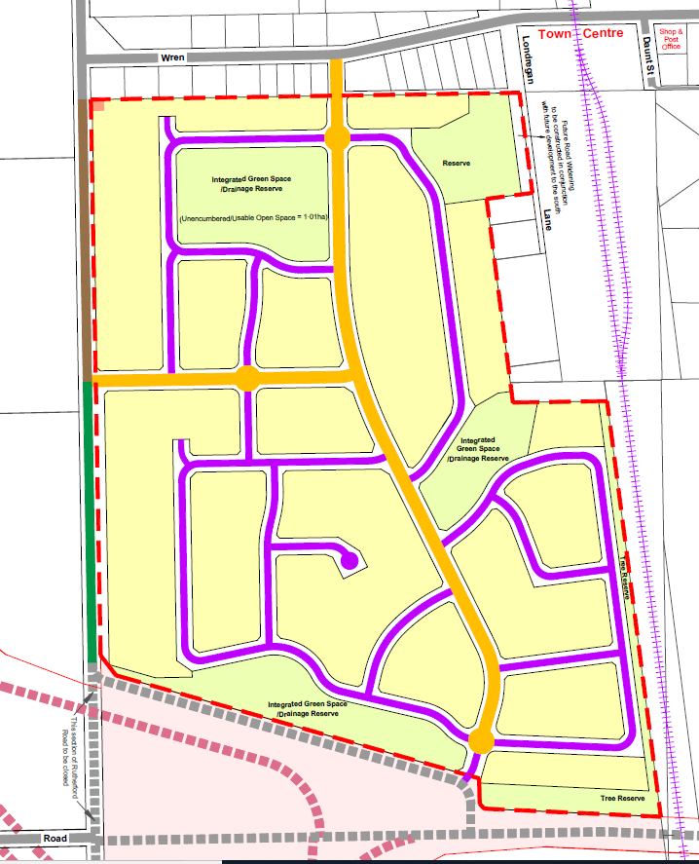

July 2021

Contents
Toolamba Precinct Structure Plan
1 Introduction 2
1.1 How to Read this Document 3
1.2 Land to which this applies 3
1.3 Background Information 4
1.4 Pre-development Agreement 4
1.5 Development Staging 4
2 Outcomes 5
2.1 Vision 5
2.2 Objectives 5
2.3 Structure 6
2.4 Land Budget 6
3 Implementation 7
3.1 Residential Area 7
3.2 Public Open Space & Drainage Retardation/ Wetland Areas 8
3.3 Access Network 9
3.4 Utilities 11
4 Plans 12
Plan 1 – Locality Context 12
Plan 2 – Site Analysis 13
Plan 3 – Structure Plan 14
Plan 4 – Road Hierarchy 15
Typical Road Cross Sections 16
Plan 5 - Bicycle and pedestrian network 17
Plan 6 – Public open space and existing vegetation 18
Staging Plan 19

Introduction
The Toolamba Precinct Structure Plan (PSP) has been prepared by Greater Shepparton City Council in association with referral authorities and agencies, and major stakeholders.
The PSP:
- Is a strategic plan which guides the delivery of a quality township environment
- Sets a vision for how land should be developed and describes the outcomes to be achieved by the future development
- Details the form and conditions that must be met by future land use and development
- Provides a framework for the use and development controls that apply in the Schedule 3 to Clause 37.07 Urban Growth Zone and planning permit which may be granted under the schedule to this zone
- Provides developers, investors and local community with guidance about future development

The PSP is informed by:
- The Planning Policy Framework set out in Clauses 10 to 19 (incl.) of the Greater Shepparton Planning Scheme;
- The Local Planning Policy Framework of the Greater Shepparton Planning Scheme;
- The Greater Shepparton Housing Strategy (May 2011) – GSHS;
- The Cultural Heritage Management Plan (2010) which sets out the requirements for the management and preservation of areas of archaeological sensitivity;
- The Flora and Fauna Assessment (May 2012) which sets out the requirements for the protection and management of native vegetation and fauna within the PSP area;
- The Traffic Impact Assessment (updated, May 2018) which considers the existing traffic volumes and movements and sets out recommendations in relation to road widths, intersection design and traffic calming devices;
- The Stormwater Management Plan (April 2016) by Stormy Water Solutions which considers the major drainage, flooding and water quality management issues of the subject site and provides for the site to be developed without adverse downstream drainage impacts;
- The Toolamba and District Community Plan (May 2011) which outlines the vision and aspirations of the community of Toolamba; and
- The Toolamba Precinct Structure Plan Background Report (updated, July 2016).

How to Read this Document
This precinct structure plan (PSP) guides use and development where a planning permit is required under the Urban Growth Zone, where this structure plan is referred to within a Schedule to the zone.
- The Vision must inform all the outcomes of the precinct.
- Outcomes are what development of the precinct must achieve.

The PSP is set out in a number of “elements”
- Requirements must be adhered to in developing the land. They will usually be demonstrated in an application for a planning permit for development of the land, including on plans submitted for endorsement.
- Guidelines express how discretion will be exercised by the responsible authority in certain matters that require a planning permit. An outcome may be achieved by more than one method, including an alternative to the guideline, to the satisfaction of the Responsible Authority.
- Conditions are to be achieved by the planning permit application process. They may be demonstrated on the endorsed plans and/or included as a condition on a permit, as relevant, to the satisfaction of the Responsible Authority.
Plans are a spatial expression of the outcomes. Development may take alternative forms from that described in plans, tables and figures provided it achieves the outcomes and meets the requirements in this structure plan.
Not every aspect of the land’s use and development is addressed in this structure plan and the Responsible Authority may manage development and use and issue permits as relevant at its general discretion.

Land to which this applies
The land to which this PSP applies is approximately 44 hectares and is located directly to the southwest of the existing Toolamba township. The land is bounded to the north by existing township properties along Wren Street; to the east by the railway line; to the south by the Public Acquistion Overlay associated with the future Goulburn Valley Highway Shepparton Bypass; and to the west by Rutherford Road.
The PSP area is shown on Plan 1.

Background Information
Detailed background information on the PSP area - including its local and regional context, history, landform and topography – as well as greater detail of the PSP features and objectives – township character, community facilities, biodiversity and heritage values, drainage, open space and urban form are contained within the background report, which has informed the preparation of the PSP.

Pre-development Agreement
The landowner has entered into an Agreement with the Council under Section 173 of the Planning & Environment Act to set out certain matters pertaining to the development, specifically to set out certain infrastructure that is to be provided commensurate with development.

Development Staging
A Staging Plan has been prepared to assist interpretation of the Structure Plan and the preparation of the pre-development agreement. However, the Staging Plan does not mandate the staging for future residential development. The actual staging of development may change at any future point in time, subject to approval by the responsible planning authority under the planning permit approval process.

Outcomes

Vision
Toolamba is a small regional township serviced by a general store, community centre, primary school, kindergarten and local recreational facilities. The broader area features open farm land, the Goulburn River and adjoining river flats.
The future residential development of the PSP study area will retain and enhance the existing township character, with wide open streets, generous lots, public open spaces and links to the town’s existing facilities. Increased community access to the area will be achieved through shared cycling and pedestrian paths along existing desire lines and new residential streets.
The PSP vision is for new and existing residents to share in a sustainable community that provides day to day services, enhances local connectivity and continues the established strong sense of identity of their township by retaining the township feel.

Objectives
The following points describe the desired outcomes of development of the precinct and guide the implementation of the vision:
- Recognise the character and history of the area by drawing on the existing identity of Toolamba;
- achieve a diversity of streetscape and open space outcomes to enhance local character and amenity, ensuring legible connections into the existing town;
- create a mixture of generous lots that retains the rural small town character by encouraging open front yards and generous house setbacks;
- utilise and incorporate the natural values of the precinct by retaining existing vegetation where it can be incorporated into the developed landscape (i.e. in parks and other locations where survival can be managed);
- promote the enjoyment and public use of the Goulburn River environs as a significant recreation feature of the region;
- deliver an integrated network of local parks that meets the needs and aspirations of the neighbourhood;
- healthy lifestyles are encouraged through the extensive network of open spaces, pedestrian and cycle linkages;
- provision of a central spine road that provides a priority connection route that enables logical and simplified navigation within the precinct, directing traffic to external movement corridors and activity nodes, while discouraging through movements by external traffic;
- promote greater housing choice through the delivery of a variety of lots – within the range expectant of a small regional town – that are capable of accommodating a variety of dwelling types;

- deliver sufficient residential densities within a walkable catchment to support vibrant and viable town centre; and
- provide for the transition from larger residential properties to more conventional residential densities by the provision of reticulated sewer to all residential lots.

Structure
The PSP area is divided into the following areas:
- Residential areas –the land to be developed for residential lots.
- Integrated Public Open Space and drainage retardation/ wetland areas which are located within pre-existing drainage sub-catchments and make use of natural drainage flow paths through and from the site.
- Access network, which includes all internal collector and access streets contained within the PSP.
The balance of the land (located to the south of the future Bitcon Road extension) has an area of 35.38 hectares, is significantly affected by the Public Acquisition Overlay and does not form part of the PSP area.

Land Budget

Description | Area (hectares) | % of GDA
GROSS DEVELOPABLE AREA (GDA) | 43.99 | 100
ROADS | 10.94
Rutherford Road widening | 0.36
Internal subdivision roads | 10.48
OPEN SPACE | 7.40 | 16.82
Integrated Green Space | 5.13
Encumbered by drainage infrastructure | 4.12 | 9.37
Unencumbered - Usable for passive recreation | 1.01 | 2.30
Tree Reserves | 2.27
Reserve - Usable for passive recreation | 1.17 | 2.66
Tree Reserve/buffer | 1.10 | 2.50
Total Public Open Space (usable for recreation) | 2.18 | 4.96
RESIDENTIAL LOTS | 25.65 | 58.31

Implementation

Residential Area
The requirements and guidelines for the Residential Area are as follows:

Requirements
R1 | Lots must generally range between 800m² and 1,200m² in area
R2 | Lots must be configured with full width frontages so that housing can be oriented towards the road to which it fronts
R3 | Lots must be orientated and configured to encourage house design with a northern aspect
R4 | Existing remnant native trees are to be retained within the urban layout wherever practicable. Trees retained within lots are deemed to have been lost and must be offset in accordance with Clause 52.17 of the planning scheme
Guidelines
G1 | Design of dwellings should add to the precinct character by providing attractive street address that encourages passive surveillance and visual interest
G2 | Dwellings opposite open space to facilitate passive surveillance via windows and access points.
G3 | Front fences are strongly discouraged.  Fencing on side road boundaries of corner lots should be kept to a minimum.
G4 | Fences forward of the building should not be more than 1.2 metres high
G5 | Smaller lots should generally be located close to Wren Street.
G6 | Driveways should be separated a minimum of 2m apart from one another, to support street tree and boundary planting.
Conditions
C1 | Before subdivision that creates lots containing native vegetation, or the carrying out of any associated works, or removal of any native vegetation an offset credit must be obtained to the satisfaction of the responsible authority, in accordance with Clause 52.17 of the planning scheme.  Any removed trees must be retained on site and/or made available to be positioned in reserves for habitat.

Public Open Space & Drainage Retardation/ Wetland Areas
The requirements and guidelines for Public Open Space and drainage retardation/wetlands are as follows:

Requirements
R5 | The area of native vegetation at the northeast corner of the PSP site must be retained in a reserve vested to the Council. The reserve must be retained and managed by the Council for its biodiversity values.
R6 | The layout (including the design and width) of drainage infrastructure, including wetlands and retarding basins must be to the satisfaction of the Responsible Authority and Goulburn Murray Water.
R7 | All open space, including that encumbered by drainage infrastructure, must – where practicable - abut a road. Where this cannot be achieved, a suitable interface and active frontage must be provided to the satisfaction of the responsible authority.
R8 | All landscaped areas must be designed for low maintenance to the satisfaction of the Responsible Authority.
R9 | All public landscaped areas must be planted to the satisfaction of the Responsible Authority.
R10 | Appropriately scaled lighting must be installed along major pedestrian thoroughfares traversing public open space and cycling networks to the satisfaction of the Responsible Authority.
R11 | Land designated for passive recreation must be designed, finished and maintained to the satisfaction of the Responsible Authority prior to its transfer.
R12 | Fencing of parkland (if any) must be low scale and visually permeable to facilitate public safety and surveillance and only provided where it is deemed necessary to prevent indiscriminate vehicle access.
R13 | The three (3) scarred trees – identified in the Rutherford Road Toolamba Cultural Heritage Management Plan (Heritage Insight Pty Ltd) 2010 - must be excluded from development, protected during construction with fencing and signage, and managed thereafter in accordance with an approved conservation plan, as set out in the recommendations of the Rutherford Road Toolamba Cultural Heritage Management Plan (Heritage Insight Pty Ltd) 2010.
R14 | The first stage of the development must a include a neighbourhood park with an area of at least one hectare and containing an activity node incorporating seating, exercise stations or other similar facilities to the reasonable satisfaction of the responsible authority

Guidelines
G7 | Where appropriate, the use of indigenous trees is encouraged along streets and wetlands in accordance with the Landscape Plan Guide for Developments in Campaspe Shire Council, City of Greater Shepparton and Moira Shire Council.
G8 | Local parks should provide infrastructure to cater for a broad range of users and support informal recreational activities such as seating, rubbish bins, etc.
G9 | Public open space landscaping should contribute to habitat for indigenous fauna species, in particular arboreal animals and birds to the satisfaction of the responsible authority.

Access Network
The requirements and guidelines for the access network – including roads, shared paths and pedestrian paths are as follows:

Requirements
R15 | The street layout for the subdivision must:  - Form a coherent network across the precinct, focussed around central connector streets that lead road users to Wren Street and Rutherford Road  - Be of a general grid formation, so as to provide access options and good connectivity between dwellings  - Ensure that no dwelling is disadvantaged by poor access to open space or facilities
R16 | Access to Wren Street and Rutherford Road must be to the satisfaction of the Responsible Authority.
R17 | Provide active frontage (lots facing) Rutherford Road.
R18 | Provide land for a future widening of Londregan Lane, which may be required as part of any potential future development of 19 Londregan Lane.
R19 | New residential access and collector streets as shown on the Structure Plan must be in accordance with the Infrastructure Design Manual, generally as shown on the Typical Cross Sections drawing within this report, or as otherwise agreed by the Responsible Authority.
R20 | Staging of the subdivision is to provide for timely connection of road links between properties and to the connector and arterial road network and the off-road pedestrian and bicycle network to the satisfaction of the Responsible Authority.
R21 | Pedestrian paths must be provided on all internal collector and access streets where fronted by lots.
R22 | Pedestrian and cycling crossing points must be provided at all intersections and on key desire lines.
R23 | Public lighting must be LED or equivalent high efficiency luminary
R24 | Where existing remnant native trees are to be retained and positioned within the road reserve – particularly along Rutherford Road - measures must be taken to ensure their survival, both during and after construction.
R25 | Remnant native scar trees must be protected during construction and retained thereafter as set out in the recommendations of the Rutherford Road Toolamba Cultural Heritage Management Plan (Heritage Insight Pty Ltd) 2010.
Guidelines
G10 | Intersections of internal connector streets with Wren Street and Rutherford Road should be designed to facilitate the safe and convenient movements of both vehicles and pedestrians.
G11 | Use of culs-de-sac should be minimised and should not detract from convenient pedestrian or vehicle connections.
G12 | Existing roadside trees are to be retained (as much as practicable) by providing a widened road reserve so that root zones are not disturbed by trenching and infrastructure and through careful consideration of vehicle access points
G13 | Cycle connections should be designed to allow for safe and convenient transition between on-road and off-road network.
G14 | Street trees should contribute to habitat for indigenous fauna species, in particular birds.
G15 | Street trees should be a mix of larger canopy trees and mid-level trees, with a minimum of 80% native or indigenous species.
G16 | Street trees should be planted at a minimum ratio of one street tree per lot or every 20 metres, whichever is lesser.

Utilities
The requirements and guidelines for provision of utility services are as follows:

Requirements
R26 | All lots must be provided with reticulated potable water and reticulated sewer to the satisfaction of Goulburn Valley Water.
R27 | All lots must be provided with electricity and telecommunications (including access to broadband network) to the satisfaction of the relevant service.
R28 | All new electricity supply infrastructure (excluding substation and cables with a voltage greater than 66kv) must be provided underground.
R29 | All lots and roads to be connected to an underground piped drainage system.
Guidelines
G17 | Any new electricity substations required to service the development should be located outside of key view lines or appropriately screened with vegetation.
G18 | The design of subdivision electricity infrastructure must consider the practicality of removing any existing above ground electricity lines by re-routing lines underground through the subdivision.

Plans

Plan 1 – Locality Context

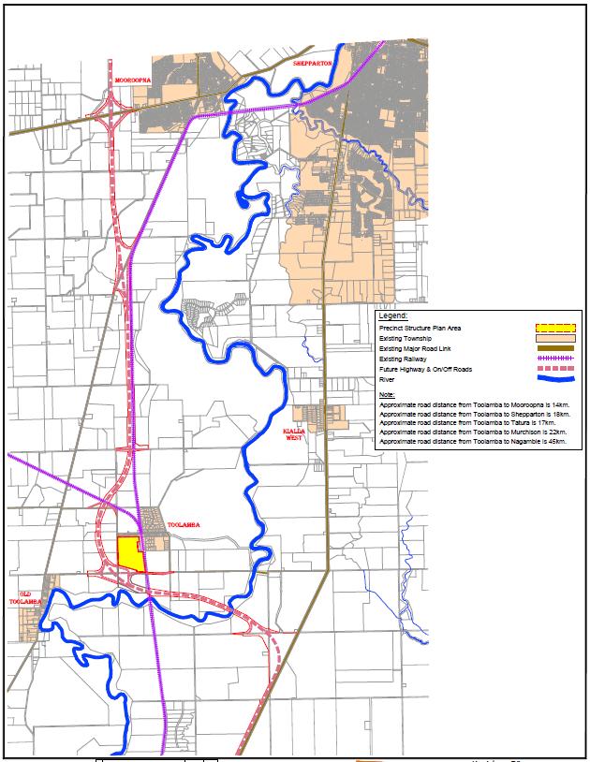

Plan 2 – Site Analysis

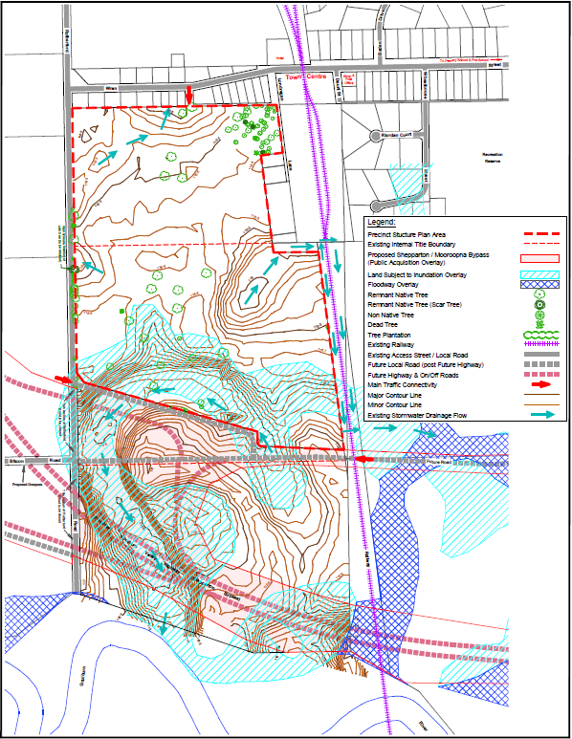

Plan 3 – Structure Plan

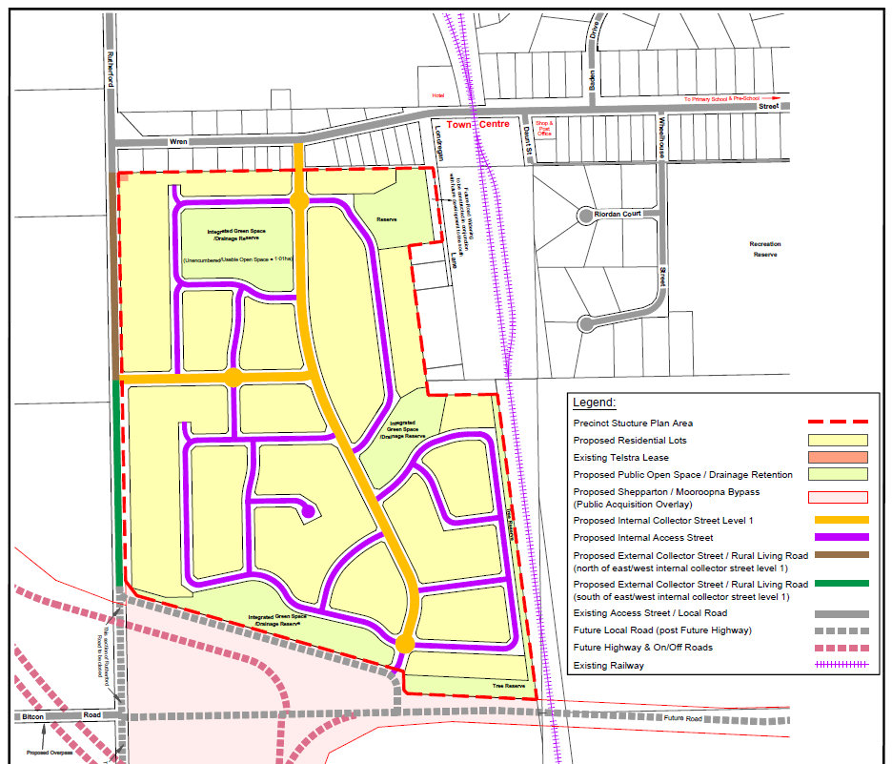

Plan 4 – Road Hierarchy

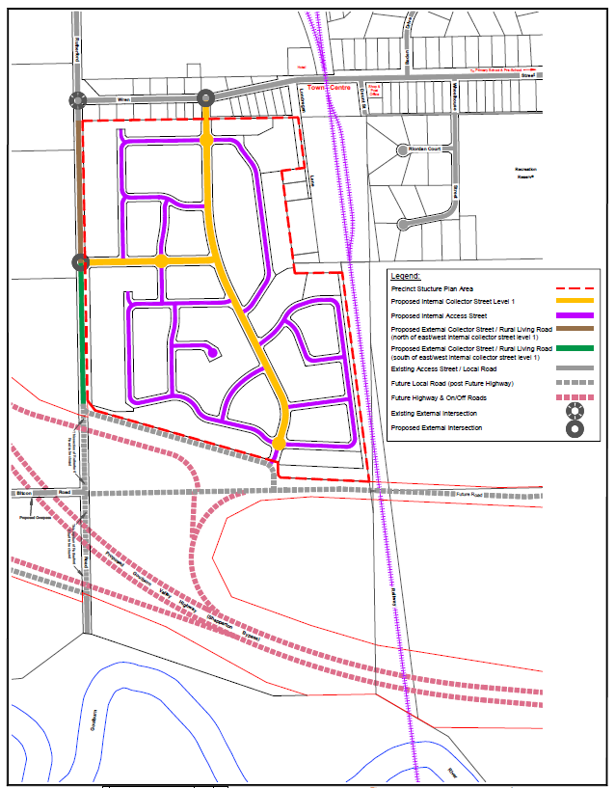

Typical Road Cross Sections

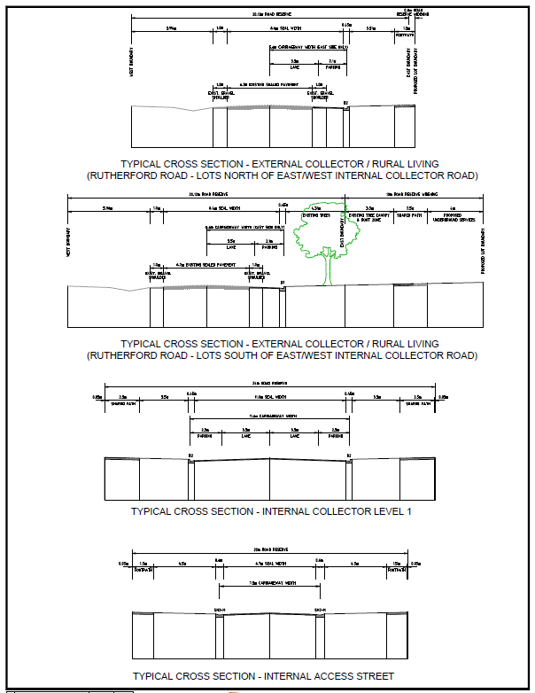

Plan 5 - Bicycle and pedestrian network

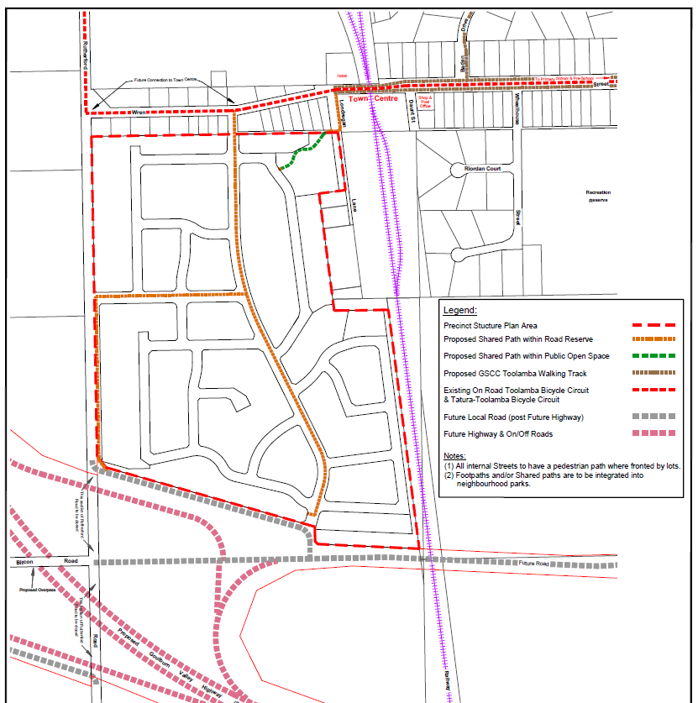

Plan 6 – Public open space and existing vegetation

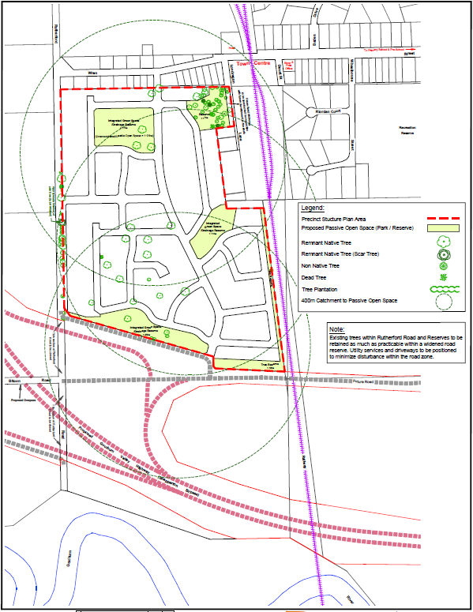

Staging Plan

